Smart Water Fountain
DHAANISH AMHED COLLEGE OF ENGINEERING
ECE DEPT
PADAPPAI-601301

Introduction

1.1 Objective:
Today, more people around the world have pets than ever before. According to American
Pet Products Association’s survey in 2020, 67% of U.S. households own a pet which is about 84.9 million homes. This proportion has been increased by 20% in thirty years [1]. Breakdown of the pet types, cats and dogs are the most popular animals, they contribute to about 80% of all pets. Same trend happens all over the world. On average, one in three households own a dog globally and about a quarter of households worldwide own a cat [2]. Both cats and dogs prefer flowing water. A source of fresh clean running water can encourage pets to drink. Drinking a certain amount of water daily plays an important role in long-term health for pets, especially cats. As a result, a water fountain is essential to most households having cats or dogs as pets. However, we can not ensure the water quality when we are away from home for several days. It can happen when pets have finished all remaining water in the water fountain, or water has been polluted somehow by the pet. These can cause the pet to be unwilling to drink water from the fountain.
Our goal is to design a smart water fountain that can monitor the water quality and automatically replace water when polluted(not healthy) or running out. We will use sensors to measure the water quality. Common water quality measurement factors include temperature, Ph-value, conductance, turbidity and hardness [3]. Considering the pollution at home can only affect limited factors, we choose temperature, Ph-value and conductance to be the three properties used for calculating water quality in our water fountain. These data will be collected, calculated, and reflected to the user in terms of “Good”, “Average” and “Bad”. The water fountain is also designed to self-filter the water every time when water is pumped through the submersible water pump.
1.2 Background:
There have been quite a lot of water fountain products on the market[4], while most of them have only filtration as an extra function besides providing running water. [5] The size of the water fountain limits the capacity of the water source that most water fountains cannot store enough water for multiple pets to drink in several days.
Our water fountain can be connected to an extra water source that provides enough water for long-term usage. The link is adaptable to universal water bottles for convenience. The sufficient water source as well as automatic replacing and refilling function enable pet owners to leave home for several days without worrying about water supply for pets.
1.3 Physical Design:
A pictorial representation of your project that puts your solution in context. Not necessarily restricted to your design. Include other external systems relevant to your project (e.g. if your solution connects to a phone via Bluetooth, draw a dotted line between your device and the phone). Note that this is not a block diagram and should explain how the solution is used, not a breakdown of inner components.

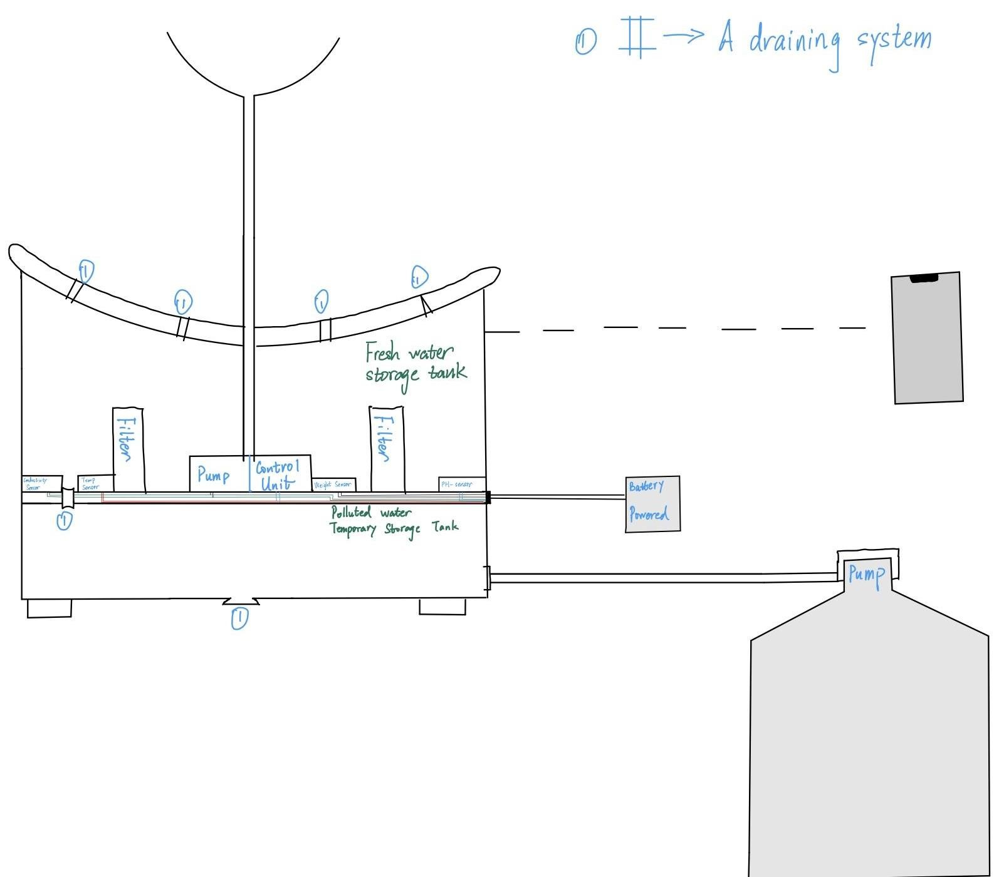
Figure 1 Smart Fountain Physical Diagram

1.4 High-level requirements list:
- Able to drain the polluted water and replace it with fresh water. Specifically, the polluted water will be drained by a motor-controlled valve to the “polluted water temporary storage tank” part. After completing the draining process, fresh water will be pumped from the general water supply(as described in the right down corner of the physical design, Figure 1).
- The fountain must accurately monitor the water quality, including measuring water temperature up to 48.89C and pH values between 6.5 and 8.5.
- Able to be connected to the users’ devices through WIFI. Prompt feedback from the smart water fountain to users’ interface with relevant information including the remaining water level and water quality index: ‘Good’, ‘Average’ and ‘Poor’.

Design
The block diagram below is a general design of our solution. We divide our design into four modules, including Power Supply, Control Unit, External Control, and Mechanical Unit. Details of each unit is presented in the diagram and described in the next section.
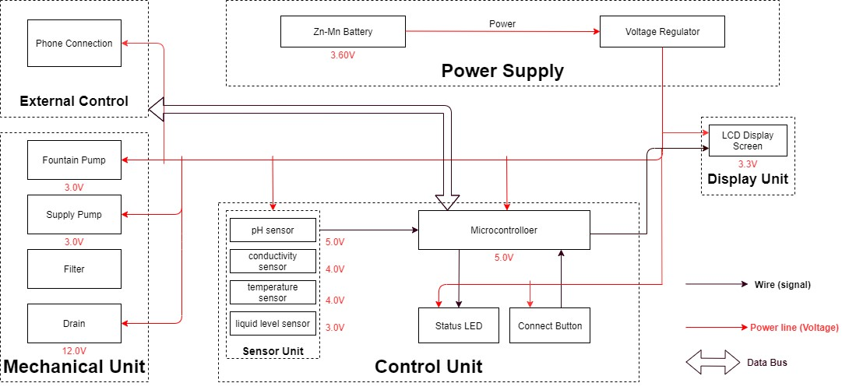
Figure 2 Block Diagram of Smart Water Fountain

2.1 Sensor Unit
This block contains the four sensors. The data acquired from the sensors will be transmitted to the control unit. Control unit will then have some logic designed to send corresponding signals to control other blocks of the water fountain. At the same time, the display screen on the water fountain will display the readings along with the determined water quality level and remaining water quantity.
For the PH-value sensor, temperature sensor and conductivity sensor, values will be retrieved and calculated to determine the overall water quality level. When poor water quality is determined, the water replacement procedures will take place. The weight sensor readings will be used to determine the amount of fresh water left in the water tank.
2.1.1 Temperature Sensor:
A water-proof temperature sensor is going to be used. Part number from sparkfun is: DS18B20 [6]. This temperature sensor is compatible with a relatively wide range of power supply from 3.0V to 5.5V. The measured temperature ranges from -55 to +125 celsius degrees. Between -10 to + 85 degrees, the accuracy is up to +-0.5 degrees. This sensor can fulfill all requirements needed for this project.
2.1.2 PH-sensor:
PH value is a valued indicator of water quality. This PH-sensor[7] works with 5V voltage, which is also compatible with the temperature sensor. It can 6measure the PH value from 0 to 14 with an accuracy of +- 0.1 at the temperature of 25 degrees.
2.1.3 Conductivity sensor:
Conductivity sensor is also part of the water quality assessment. The input voltage is from 3.0 to 5.0V. The error is small, +-5%F.S. The measurement value ranges from 0 to 20 ms/cm which is enough for water quality monitoring. [8]
2.1.4 Liquid Level Sensor:
This sensor [9] is responsible for reflecting how much freshwater is left in the water tank. When the water level is low, fresh water will be pumped to the water tank to ensure the water fountain keeps running with freshwater. This sensor is 0.5 Watts. For water level from 0 to 9 inches, the corresponding sensor outputs readings from 0 to 1.6. From that, the quantity of freshwater left can be determined.

2.2 Display unit:
2.2.1 Screen:
The screen will be used to display the readings from the sensors in a real-time manner.[10] In addition, other necessary information will also be displayed. As described in the sensor part, the water quality and remaining water quantity will be displayed. The screen will be programmed so that it makes it easy for users to read information.
This 20*4 LCD display screen is going to be used to display the relevant information. After programming the screen, a conclusion of water quality(Good, Average, Poor) will be displayed along with the remaining water level.
2.3 Power Supply Unit
2.3.1 Zn-Mn Battery
The Zn-Mn battery must be able to continuously support the functioning of the circuit, display unit, and the mechanical unit.
Requirement: Commercial batteries will be used to maintain a continuous 3.60V power supply for at least 24 hours. If the chosen battery is not powerful enough, 120V power outlets will be considered.
2.3.2 Voltage regulator
The integrated circuit will regulate the power supply for each module to maintain their functionality. This chip must be able to handle the maximum voltage supplied by the battery (3.60V ± 0.5V) while ensuring the voltage at each module does not exceed their limit.
Requirement: Must maintain thermal stability below 100°C.
2.4 Mechanical Unit
2.4.1 Fountain Pump
The fountain pump [14] must maintain a continuous water supply through the fountain mechanism. The pump must work 24 hours a day, 7 days a week unless the user manually turns off the power supply.
Requirement 1: The fountain pump must lift a cylindrical water stream of diameter 6mm for a height of 400mm.
Requirement 2: The fountain pump must serve for a duration of 2 years without maintenance or replacement under heavy workload.
Requirement 3: The fountain pump should have an operational condition around 3V, 200mA.
2.4.2 Supply Pump
The supply pump must function when a low water level alert is raised. While no water supply is requested, the pump must prevent water flow between the main supply and the fountain.
Requirement: The supply pump should have an operational condition around 3V, 200mA.
2.4.3 Filter
The filter must maintain the water quality through controlling the pH value and conductivity of the water.
Requirement 1: The filter must have a cost less than $5 each for frequent replacement. Each new filter must serve a duration no less than 3 month.
Requirement 2: The filter must be designed for easy removal and installation, while the connection mechanism must have a low degenerate rate when submerged in water.
2.4.4 Drain
The drain [13] must be able to hold and release water in the fountain. When water in the fountain should be replaced, the faucet should automatically drain the fountain once instruction is received from the integrated circuit.
2.5 Control Unit
This unit contains the control unit which does the following things:
- When the weight sensor reports a weight less than the minimum weight setting, the control unit will send an alert signal to the user and then control the water supply unit to refill the water fountain with a certain amount of water.
- Computes the water quality with data transferred from the three sensors in the water quality module and sends the result in terms of “Good”, “Average” or “Bad” to the user.
- If the water quality is “Bad”, the control unit will control the drain module to drain the water in the fountain and then control the water supply to refill.
- Water quality result is sent to the user with wireless connection and screen display as described above in the display unit.(unsure about keeping this function)
2.6 Risk Analysis:
2.6.1 Control Unit Block:
One of the most challenging points in this project is the precise control of the control unit between different blocks. To react accurately and promptly based on the results from the sensors is the key. The control unit needs to accommodate the mechanical and the electrical part so that the pumps, draining system can work collaboratively smoothly. From acquiring the data from sensors, analyzing the data, communicating and displaying the data to users, and then sending signals to activate the corresponding actions(drain or add fresh water), these are all to be performed by the control unit. Thus, it is the block that brings the greatest risk.
We will divide all the overall control unit functions into three parts: data retrieving, data manipulation, data delivering. Data retrieving is the logic used to read data from all sensors. Necessary algorithm is to be written to ensure successful and accurate data acquisition. Data manipulation is the process of calculating the water quality levels, and the formula to integrate all the data to produce a credible result. The data delivering is used to connect the control unit to the screen, displaying the necessary information as described above. This part will also be responsible for building the connection between the water fountain and the users’ phones through WIFI. 2.6.2 Mechanical Unit Block:
This is very challenging and extremely important. As most of the components will be exposed to water. Sensors, pumps, filters, draining system motors are all to be placed in the water tank. This means that we need to ensure no water can leak into the electrical-related mechanical parts. This puts pressure on the design and also the implementation. In addition, the motor-controlled valves used to drain the polluted water need to be firm when closed. Otherwise the fresh water will be leaking to the polluted water storage and the water consumption will be uncontrollable.
To achieve those points, we will make sure the designs are carefully implemented. The actual building process for the container should be proved before placing the electronic parts in.

Ethics and Safety
3.1 Mechanical Unit Block
3.1.1 I-1 of IEEE Code of Ethics:
Quoted from IEEE Code of Ethics[11]: “To hold paramount the safety, health, and welfare of the public, to strive to comply with ethical design and sustainable development practices, to protect the privacy of others, and to disclose promptly factors that might endanger the public or the environment.”
We will carefully choose the materials used to build the container. Non-toxic are sure to be used. We will prefer using reusable materials. In addition to that, the users can choose to buy reusable bottles of water for the freshwater supply for the water fountain. Those universal water bottles are safe and reusable. [12] A special connector will be designed and the universal connection is to be used. After the water in the bottle is used up, this reusable bottle can be recycled and reused. This is the most environmentally-friendly solution and complies with the IEEE Code of Ethics #I-1. It not only improves the practicality, convenience, and reduces the future cost when using the water fountain.
3.1.2 II of IEEE Code Of Ethics:
“II. To treat all persons fairly and with respect, to not engage in harassment or discrimination, and to avoid injuring others.”
the mechanical unit involves electronic components that are physically placed in the water tank. The consequence can be serious if the leakproofness is not performed properly. To maintain a safe, convenient using experience, we will be responsible for testing and ensuring all containers meet the demand. These actions must be taken to ensure the safety of using the water fountain and protect the others.
3.1.3 I-6 of IEEE Code Of Ethics:
“to maintain and improve our technical competence and to undertake technological tasks for others only if qualified by training or experience, or after full disclosure of pertinent limitations.”
All team members involved in the development of the water fountain have completed
“Laboratory Safety training” and have gained required and necessary knowledge in dealing with emergency situations. In case of accidents, proper reaction will be made to ensure the safety of people and property to the largest extent.

• Remote access: Many smart water fountains can be controlled and monitored remotely via a mobile app, making it easy to check on your pet’s water intake while you’re away from home

Why Are Smart Water Fountains Ideal for Busy Pet Owners?

Smart water fountains are ideal for busy pet owners for a number of reasons:

• Convenient: Smart water fountains are automated, meaning you don’t have to manually refill your pet’s water bowl every day. This is particularly helpful for pet owners with busy schedules or those who travel frequently

• Hygienic: The filtration system in smart water fountains ensures that the water is always clean and free of impurities. This helps to prevent the growth of harmful bacteria and keeps your pet healthy

Encourages hydration: The consistent flow of water in smart water fountains encourages pets to drink more, which is essential for their overall health and wellbeing.

• Real-time monitoring: With the monitoring features in some smart water fountains, you can keep an eye on your pet's water intake and detect any potential issues, such as a decrease in water consumption or dehydration.

Instachew PURRFLOW SMART PET FOUNTAIN

One of the top smart pet water fountains on the market is the Instachew Purrflow Smart Pet Fountain This innovative water fountain comes with a range of features that make it ideal for busy pet owners, including:

• Real-time monitoring: The Instachew PURRFLOW SMART PET FOUNTAIN lets
EXAMPLE:

Is a Smart Pet Water Fountain Right for Your Pet Family?

Over the past few years, pet water fountains have grown in popularity. They are practical, save time, and support optimal hydration in canines and felines Think about your pet family's needs in the long run as well as the benefits of pet water fountains before making a choice

The Instachew Purrflow Smart Pet Fountain is a great and budget-friendly choice for pet owners who are busy because it has a quadruple filtration system, runs quietly, and can be monitored in real time. By investing in a smart water fountain, you can provide your care, even when you’re not home

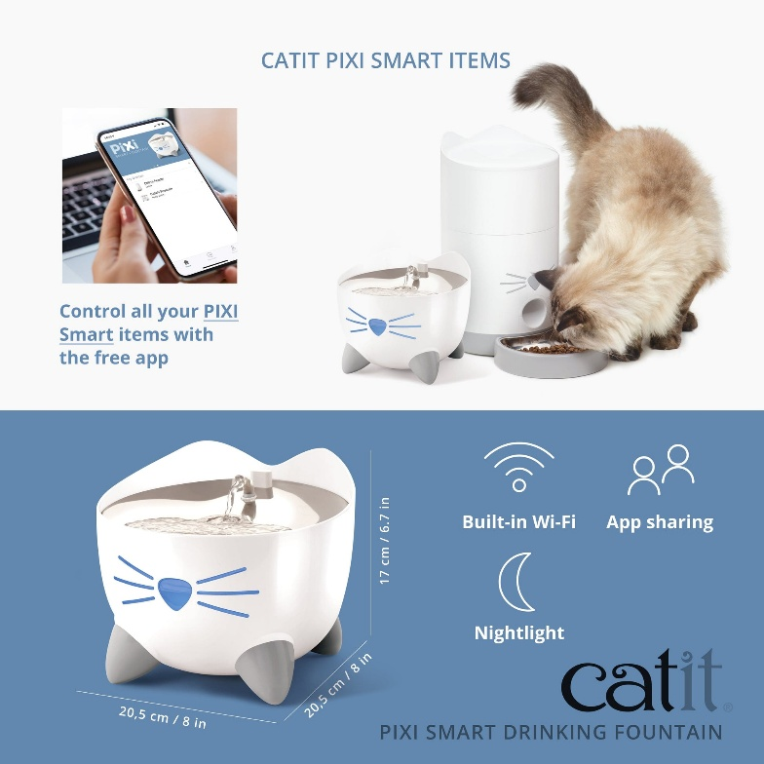

INNOVATION:

The use of this smart water fountain
Requires the use of the “eCashWater” app, Play. Payment for water is carried out inPartnership with a mobile operator.

Consumers pay for drinking water via thPartner mobile operator using the“eCashWater” app. After payment via the Mobile operator, consumers receive aCode on their mobile that allows them Draw from the fountain the amount ofWater purchased.

Each month “eWater for life” bills theMobile phone company for the amount ofWater used by smart fountains basedTheir contractual agreements

Smart Fountain Management Benefits
Ensures that the fountain water is safe and aesthetically pleasing.

Overall, smart water fountain management enhances efficiency, reduces costs, and promotes sustainable water us .
Smart water fountain management involves using technology to monitor, control, and optimize water fountains for efficiency, cost savings, and sustainability. It includes features like remote monitoring, leak detection, data analysis, and real-time adjustments to enhance the user experience while conserving water resources and reducing maintenance costs.

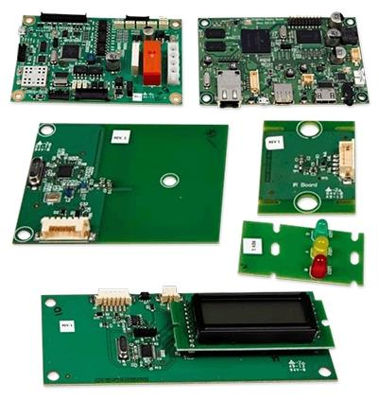

Smart Fountain Management Benefits.
1.Water Conservation: Smart systems can Monitor water usage and detect leaks,
Helping to conserve water resources andReduce waste.

2. Savings: Efficient water management Can lead to reduced water bills and Maintenance costs.

3.Sustainability: By conserving water, smart Fountain management contributes to Environmental sustainability.

4.Data Insights: Smart systems collect data That can be analyzed to make informed Decisions about fountain usage and Maintenance.

5.Preventative Maintenance: Early detection Of issues allows for proactive maintenance Preventing costly repairs.
6.User Experience: Smart fountains can Provide a better user experience by Ensuring they are operational and well-Maintained
DESTRUCTION :
Intelligent monitoring is defined as a method which is
used to monitor, control, manage and optimize the network
by using different computational methods that will provide
customers with relevant tools and information [1]. The
internet of things (IoT) forms an important part of intelligent
monitoring which connects people and devices using wireless
sensor technology. It is a fast growing research area in the
military, energy management, healthcare and many more.
The concept of IoT was proposed by Kevin Ashton to
demonstrate a set of interconnected devices [1]. IoT makes it
possible to transfer information between different electronic
devices embedded with new technology. The energy
management is possible using energy harvesting
mechanisms, which is a method of collecting energy from
natural sources such as light, vibration, pressure etc. The
combination of technologies such as Wireless sensor network
(WSN), Radio frequency identification (RFID), Energy
harvesting(EH) and Artificial Intelligence (AI) helps IoT to
flourish widely.
Water distribution system(WDS) is a very important
research area that affects the economic growth of our country.
WDS mainly have two issues, first is the water loss due to
leakage and the second is that it is prone to contamination. It
is affecting the health and safety of the people. According to
the report of world health organization (WHO) in 2017,
around 2.1 billion people around the world lack safe drinking
water. So there is a need to ensure the water quality and
wastage by using Iot to reduce such issue.
There are different traditional methods to collect water
datasets to measure its quality, but managing and monitoring
the data from WDS in real time is challenging as the data is
heterogeneous, data collection is time-consuming, energy
required for processing, coverage and connectivity of the
nodes in the network. By using IoT and combining
technologies such as WSN, AI and EH can be used to ensure
the water quality in real time and alerts the users to take
remedial measures.
In this survey, we look at the need of IoT in smart water
system. In the first step, a basic architecture is selected and
applied in WDS by analysing and comparing different
technologies, equipment, cost and methods to build a smart
water system. It reveals the need for an IoT architecture with
technologies combined for water distribution system. It also
takes into account of its advantages and disadvantages based
on the literature review. The selection of the best choice can
be identified for smart water system at the end of this step.
The next step involves selection of the parameters required
using IoT for water distribution. At this step, the current
issues during the selection of parameters and some suitable
suggestions are provided. Finally, an overview of the benefits
which is necessary to implement IoT in smart water system
is discussed.
The survey structure is organized as follows. Section 2
explains the basic architecture and technologies applied at
each layer in IoT for water management and section 3
specifies the parameters required to identify water quality,
section 4 provides the applications of IoT in water and section
5 explains the benefits of IoT in smart water system based on
the architecture and concluding with section 6.
II. ARCHITECTURE
There are different architectures proposed by different
authors based on the type and level of security required by
each application. A six layered architecture has been proposed
in [2] by combining Web services, RFID and WSN whereas a
five level architecture has been mentioned in [4] based on
telecommunication management network. The basic and
simple architecture [3] consists of three layers which are
perception, network and application layer. This architecture
will be used in the review paper focusing on WDS.
A. Perception Layer
The main use of the perception layer is to connect devices
and collect data for processing from the IoT network. This
layer consists of sensors, EH devices when applied to WDS.
Different types of sensors are available commercially

Which is used to detect water monitoring in real time. A One among the sensors to identify temperature, water flow, pH etc. Another one is kapta 3000 AC4 to measure chlorine, temperature, pressure and conductivity of the water and it costs around 3200 pounds whereas spectro::lyser is another one to monitor colour, turbidity, COD, BTX O3 etc. with a longer range and costs about 11000 pounds. Smart water solution by libelium is another sensor in identifying water contaminants and costs around 5000 pounds [5], [6]. The choice of the water quality sensor depends upon the cost, efficiency and the selection of the water quality attributes.

Energy harvesting is a method of collecting energy from Different natural sources such as light, wind, vibration etc.
And converting it into electricity to power up a device or Extend its battery life.

COMMERCIALLY AVAILABLE WATER QUALITY SENSORS
Energy harvesting methods are gaining more research interest Each year due to their different properties. The new energy Harvesting methods and their desirable properties such as low Cost, efficiency, availability and high robustness could benefit The water management system

Techniques and energy harvesting methods suitable for water Monitoring are the solar cell, piezo electric, electro-magnetic, Fuel cell and thermo-electric. The practical implementation of Solar cell seems to be difficult as the transferring of energy to Underground water pipelines will be difficult whereas the fuel Cell uses a chemical reaction to generate power which will be A slow process. The piezoelectric, electromagnetic andThermoelectric are the other three methods which are used Widely for monitoring water pipelines

2 provides a comparison of these three techniques in the Wireless network. The selection of the harvesting method was Based on considering its advantages and disadvantages that
Were analysed during the literature.]

Harvesting

Technique Advantages Disadvantages Piezo-electric
High efficiency,.

B. Network Layer

The network layer of IoT in WDS combines processing, Managing and transmission of the data passed from the Perception layer. This layer also helps in managing the Network devices and communication technologies for
Transmission.

The communication technology is classified into two Based on the range of transmission. The cellular technology is Used when long-distance transmission is required by using 2G,

In. It requires more powerConsumption which makes them not much feasible for WDN.
The short range protocols include Zigbee, 6lowpan, Radio Frequency identification (RFID).
To use for measurement. The 6lowpan is an IP based protocolWhich can be easily connected to another IP network without Any gateways. Another advantage is its low cost and power Consumption. It supports both star and mesh topology.

(Low Power Wide Area Network) is another protocol which Gained public interest due to its low power consumption, costAnd high data rate when applied in IoT and it uses the star Topology. Zigbee is a widely used low power Density.
There is a one-dimensional garden of length N. In each position of the N length garden, a fountain has been installed. Given an array. A[]such that a[i] describes the coverage limit of ¡th fountain. A fountain can cover the range from the position max(I – a[i], 1) to min( I + a[i] , N). In beginning, all the fountains are switched off. The task is to find the minimum number of fountains needed to be activated such that the whole N-length garden can be covered by water.

PROGRAM UNDER PYTON SCRIPT:

Examples:

Input: a[] = \{1, 2, 1\}

Output: 1

Explanation:

For position 1: a[1] = 1 , range = 1 to 2

For position 2: a[2] = 2 range = 1to * 3

For position 3: a[3] = 1 , range = 2 to 3

Therefore, the fountain at position a[2] covers the whole garden.

Therefore, the required output is 1.

Input: a[]= \{2, 1, 1, 2, 1\}

Output: 2

TEAM MEMBERS NAME:
A.MADHUMITHA
B.YOGAPRIYA
S .SARASWATHI
R.BHAVADHARANI
AFRA FATHIMA

